

Buenos Aires, August 4th, 2017.

Dear Mrs. Valeria Sholohova,

This is in order to inform you that the FIMBA Board, at the General Meeting in Montecatini, Italy, has made the decision to appoint you as FIMBA Representative in Russia for the period 2017-2019.

I attach the FIMBA Representative Regulations.

We kindly ask you to accept or deny this appointment in the next five days. In case of your acceptance we kindly ask you to send us an updated CV with your photo attached.

Congratulations for your designation and we wish you a long and successful trajectory in the Maxibasketball World Wide Movement.

Sincerely yours.

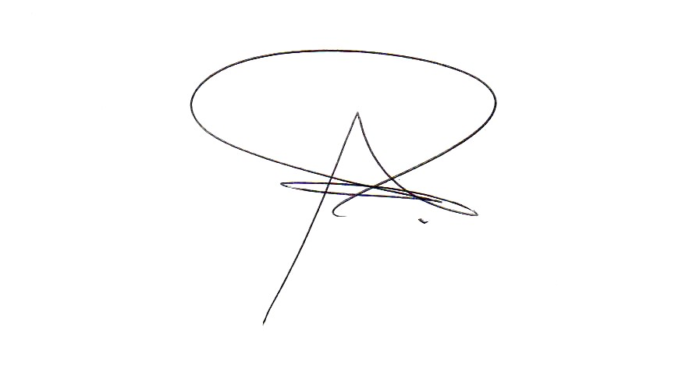

Dr. Agustín Rodríguez Lamas
Operative Director

